Worked example . Form a band, version 1

This program repeatedly reads the names of musical instruments and adds them to a list. The program stops when the **length** of the list reaches three.

|  |  |  |  |
| --- | --- | --- | --- |
| 1  2  3  4  5  6  7 | print("Let's form a band")  band = []  while len(band) < 3:   |  |  | | --- | --- | | print("Pick an instrument:")  instrument = input()  band.append(instrument) | Add instrument . |   print(band) |

Worked example . Form a band, version 2

This program repeatedly reads the names of musical instruments and adds them to a list. The program stops when a **guitar** is added to the list.

|  |  |  |  |
| --- | --- | --- | --- |
| 1  2  3  4  5  6  7 | print("Let's form a band")  band = []  while "guitar" not in band:   |  |  | | --- | --- | | print("Pick an instrument:")  instrument = input()  band.append(instrument) | Add instrument . |   print(band) |

**City hopping**

Task 1 .

You will develop a program that plans a European city-hopping trip, by randomly selecting cities out of a given list.

**Step 1**

**Go to** this program on Bourne to Code.

|  |  |
| --- | --- |
| 1  2  3  4 | from data import cities  from random import choice  city = choice(cities)  print(city) |

Line 1 imports the list of cities that the program will use. Note that this is **not a standard Python component**. The list has been created specifically to allow you to perform this activity.

The choice function (imported from the random module in line 2) is used to randomly select an item out of the list of cities (line 3).

**Step 2**

**Run** the program at least three or four times to see how a different European city is selected every time.

**Step 3**

**Remove** the last two line from your program.

|  |  |
| --- | --- |
| -  - | city = choice(cities)  print(city) |

Your program will now look like this

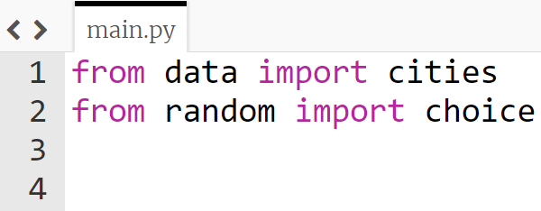

**Step 4**

**Copy and paste** the lines below in your program, do not remove the **indentation**, this is a clue. The lines with the green + are in the correct location.

**Rearrange** lines **2, 3, and 6** so that your program repeatedly selects a random city out of the cities list, and adds it to the trip list.

Your program should stop when the length of the trip list reaches **five** items.

At the end, the program should **display** the **itinerary**, i.e. the trip list.

**Tip:** Think where the **while** statement should go and when you should display the final **itinerary**

|  |  |
| --- | --- |
| +  2  3  +  +  6 | print("City hopping random planner")  print("Itinerary:", trip)  trip = []  city = choice(cities)  trip.append(city)  while len(trip) < 5: |

|  |  |
| --- | --- |
| **Example** |  |
| Note: Use this example to check your program. The actual cities contained in the itinerary are randomly selected and will be different every time the program is executed. | |
| The program displays an initial message. | City hopping random planner |
| After compiling a list of five random cities, the program displays the itinerary: | Itinerary: ['London', 'Stockholm', 'Moscow', 'Athens', 'Budapest'] |

Task 2 . No duplicates please

**Extend** the program so that every city selected is promptly **removed** from the list of **cities**. This way, no city can be selected twice for your trip.

Use **one** of the lines below in the correct location

1. **cities.insert(city)**
2. **cities.remove(city)**
3. **cities.append(city)**

**Tip:** It will need to be **indented** so think where your indented code is

Task 3 . Last stop: London

**Modify** the program so that the process of random city selection continues until London is selected and added to the trip.

**Modify** the **while** loop so it stops when “**London**” is in the **trip** list.

**Tip:** Remember the code used to keep adding instruments until the guitar was in the band, modify this so it continues until London is in the trip list.

**while "guitar" not in band**

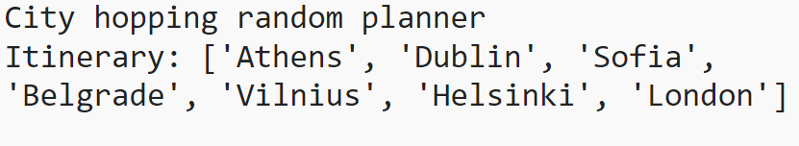

Task 4 . First stop: London

Before displaying the itinerary, consider also **inserting** London at the ***beginning*** of the trip list, so that the trip appears to be circular.

Before the last line print("Itinerary:", trip), look back to the commands from lesson 2, how would you **insert** “London” to be the **first** item in the trip list?

**Tip:** Remember which number the index number system starts with.

