# Lesson 1 – Name Badge Task – Gold/Platinum

Go to <https://makecode.microbit.org/> - **Use Google Chrome to open the website.**

Click on new project and give your program a descriptive name such as ‘Lesson 1 nameBadge’.

Click the **Basic** tools category and drag across the ***on start*** and the ***show string*** **blocks** as below.



Change the text from ‘Hello!’to your own name.

From:

 to 

Congratulations! You have created your first program for the micro:bit. You can see what the output of your program will be by using the simulator:



Once you are happy with the program it is then necessary to transfer it to your micro:bit. First you must give your **program** a name. You need to make sure that the name describes the purpose of the program so that it will be easy to find in the future.



**Method 1 – Manual Download and Copy to micro:bit**

To put your program on your micro:bit you must **Download** the **.hex** file and **copy/paste** it into the micro:bit.

Click the **Download** button.



You will see this dialogue box appear.



If you look in your **Download** folder you should find your **.hex** file. If not, it will be wherever the download folder has been set to.

If you haven’t already done so you will need to connect your micro:bit to your computer using a micro **USB** cable.



Your micro;bit should appear as a removable drive in your file system.



You now need to **Copy** (Ctrl + C) the .hex file from your **Download** folder into the micro:bit.

You can drag and drop or copy and paste the .**hex** file into the MICROBIT folder. There are some files already on the micro:bit but don’t worry about these.



When you drag the .hex file into the micro:bit you will see a progress window.



Once the file has transferred the micro:bit window will close and your program will run on the micro:bit.

**Method 2 – Automatically download to micro:bit**

You can also click the three dots next to download and then connect device. As long as your micro:bit is connected to your computer via the USB cable you will see it appear in a selection box. Click on it and then connect and then your Download button will change from a down icon to a micro:bit icon.

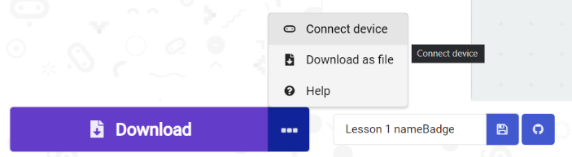

# Explorer Tasks

* Why did the text only appear once? Make the text appear forever
* Make a program that displays one of the icons below on the **LEDs**



* Make your own icon using the ***show leds*** block
* Make a program that counts down from 5 seconds to 1 second and then displays a smiley face for 5 seconds

# Final Thoughts

You have just learned to:

* Create basic programs using MakeCode
* Name and save your programs
* Upload programs to your micro:bit
* Extend your program

These are the essential skills for using a micro:bit. You will be doing this a lot in this unit!