Activity 3

Task . D is for Digital

*D is for Digital* is a book written by Brian Kernighan. The incomplete text below is from the section *Wrapup on Hardware*.

A digital computer contains a  (1)                 and  (2)                .

The  (1)                 executes simple  (3)                 very quickly. It can decide what to do next based on the results of earlier computations and  (4)                 from the outside world. The  (2)                 contains both  (5)                 and  (3)                 that determine how to process the  (5)                .

A computer is a general-purpose machine. It stores its  (3)                 in  (2)                , and one can change the computations it performs by putting different  (3)                 in the  (2)                . [...]

These are *digital* computers: everything is ultimately reduced to bits (binary digits), which individually or in groups represent information, whether  (3)                 or  (5)                , as binary numbers. [...] Anything that we are able to reduce to bits can be represented and processed by a digital computer.

**Match** the numbered gaps with the words in the right-hand column. One word will not be used.

|  |  |  |  |
| --- | --- | --- | --- |
|  | **Gaps** |  | **Words to complete the gaps with** |
|  |  |  | Data  Instructions  Input  Output  Processor  Memory |
|  |  |  |
|  |  |  |
|  |  |  |
|  |  |  |

Task . The Astro Pi

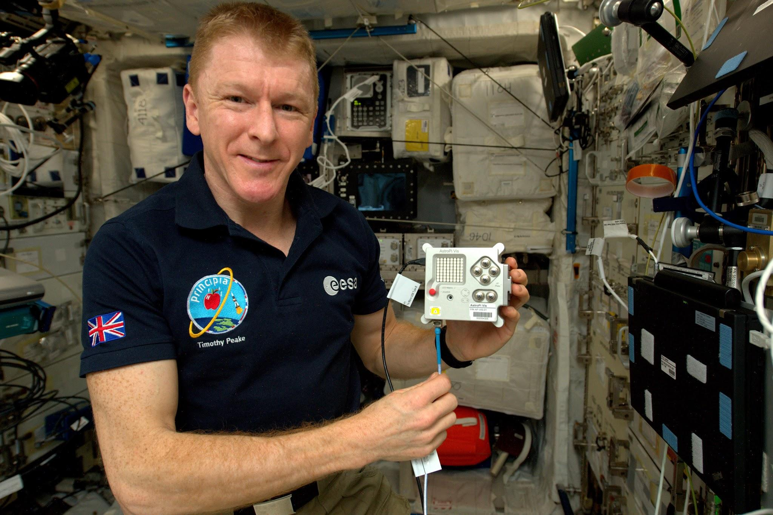

Astronaut Tim Peake using an Astro Pi aboard the International Space Station.

Source: [astro-pi.org/about](https://astro-pi.org/about/)

Image credit: ESA (European Space Agency)

The short text contains edited extracts from the European Space Agency’s website about the Astro Pi computer ([www.esa.int/Education/AstroPI](https://www.esa.int/Education/AstroPI)), and from the Astro Pi Challenge website ([astro-pi.org](https://astro-pi.org/)).

Astro Pi is a small Raspberry Pi computer developed by the Raspberry Pi Foundation (RPF), in collaboration with the UK Space Agency and the European Space Agency (ESA).

Astro Pi computers come with a set of sensors and gadgets that have the ability to ‘sense’ and make many kinds of measurements, from temperature to movement, and to output information using a special display — the 8x8 LED matrix. The Astro Pis are also equipped with a joystick and buttons.

There are two special Astro Pis that have been qualified for spaceflight and are onboard the International Space Station (ISS). They are identical, except for the type of camera they contain.

The European Astro Pi Challenge offers young people the amazing opportunity to conduct scientific investigations in space by writing computer programs that run on the AstroPi computers aboard the International Space Station.

Based on this text, and [this poster](https://ncce.io/astro-pi-poster) (ncce.io/astro-pi-poster) if you need a hint, answer the following questions:

What component(s) does the Astro Pi use to obtain **input** from its environment?

|  |
| --- |
|  |

What component(s) does the Astro Pi use to **output** information?

|  |
| --- |
|  |

How can you be sure from the text that the Astro Pi contains a **processor** and **memory**?

|  |
| --- |
|  |

**Explorer question:** Do some **research** to find out what type of **storage** the Astro Pi (or the Raspberry Pi inside it) uses.

**Tip:** Try visiting the [Raspberry Pi specs page](https://ncce.io/rpi-specs) (ncce.io/rpi-specs).

|  |
| --- |
|  |

Explorer task . What went wrong?

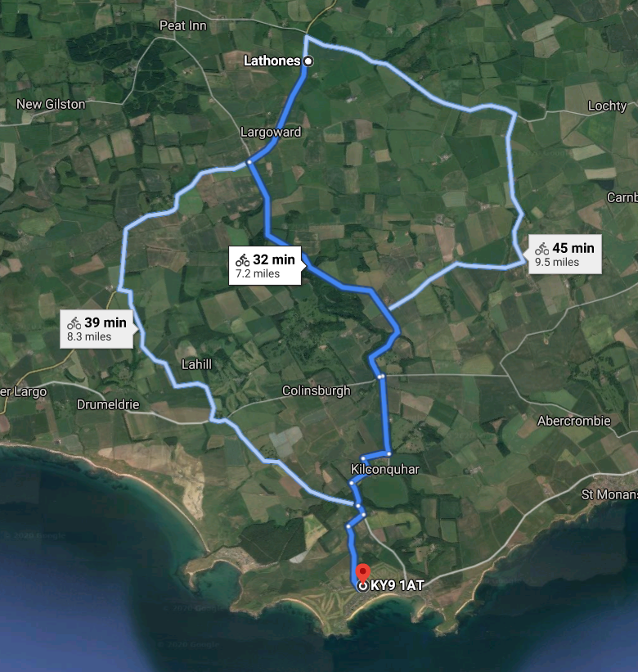

Image: Google Maps

You are on holiday and you take your bicycle for a ride. You rely on navigation software on your mobile phone to guide you to your destination.

At a couple of points, you realise that the navigational guidance is wrong; you are instructed to follow obscure country roads while sometimes missing obvious choices.

What could be the possible reasons for this? List as many as you can think of.

|  |
| --- |
|  |

This resource is licensed under the Open Government Licence, version 3. For more information on this licence, see [ncce.io/ogl](http://ncce.io/ogl).