**SEARCHING FOR INFORMATION**

Use this table in a database to search for the answers to the questions at the bottom

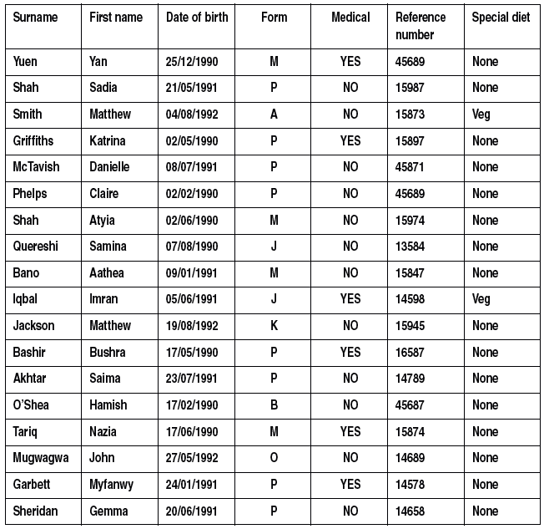

1. How many people are called Matthew?
2. How many people are in form M?
3. How many people were born in 1990?
4. How many people in form M have medical needs?
5. Who has medical needs and has a special diet?
6. Who is the oldest person in the list?