Lesson 5 Homework: Selection

**Part 1: IF/ELSE**

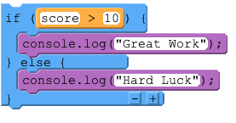

**Use the segment of code above to help you answer the questions below.**

**You should highlight or bold your answer.**

Q1. What would be displayed in the console if the score variable held the value of **5?**

1. Great Work would be outputted
2. Hard Luck would be outputted
3. Both Great Work and Hard Luck would be outputted
4. Nothing would happen

Q2. What would be displayed in the console if the score variable held the value of **10?**

1. Great Work would be outputted
2. Hard Luck would be outputted
3. Both Great Work and Hard Luck would be outputted
4. Nothing would happen

Q3. What would be displayed in the console if the score variable held the value of **15?**

1. Great Work would be outputted
2. Hard Luck would be outputted
3. Both Great Work and Hard Luck would be outputted
4. Nothing would happen

**Part 2: IF/ELSE IF/ELSE**

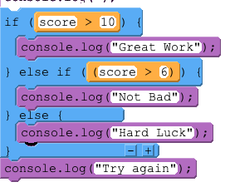

Use the segment of code above to help you answer the questions below.

Q4. What would be displayed in the console if the score variable held the value of **6?**

1. Great Work would be outputted
2. Not Bad would be outputted
3. Hard Luck would be outputted
4. Both Hard Luck and Try again would be outputted

Q5. What would be displayed in the console if the score variable held the value of **7?**

1. Great Work would be outputted
2. Not Bad and Try again would be outputted
3. Hard Luck would be outputted
4. Both Hard Luck and Try again would be outputted

Q6. What would be displayed in the console if the score variable held the value of **11?**

1. Great Work would be outputted
2. Both Not Bad and Try again would be outputted
3. Both Great Work and Try again would be outputted
4. Both Hard Luck and Try again would be outputted
5. Both Great Work and Not Bad would be outputted

This resource is licensed under the Open Government Licence, version 3. For more information on this licence, see [ncce.io/ogl](http://ncce.io/ogl).