The Antikythera mechanism

The geared mechanism was retrieved in 1900 from a Roman shipwreck, off the coast of Antikythera island.  It is of Greek origin and it is estimated that it was constructed around the end of the second century BC.  How it worked  The user of the mechanism could rotate a crank to set a date.  The device would calculate and display, through dials and indicators, the position and phase of the moon and the position of known planets, and predict solar eclipses. | 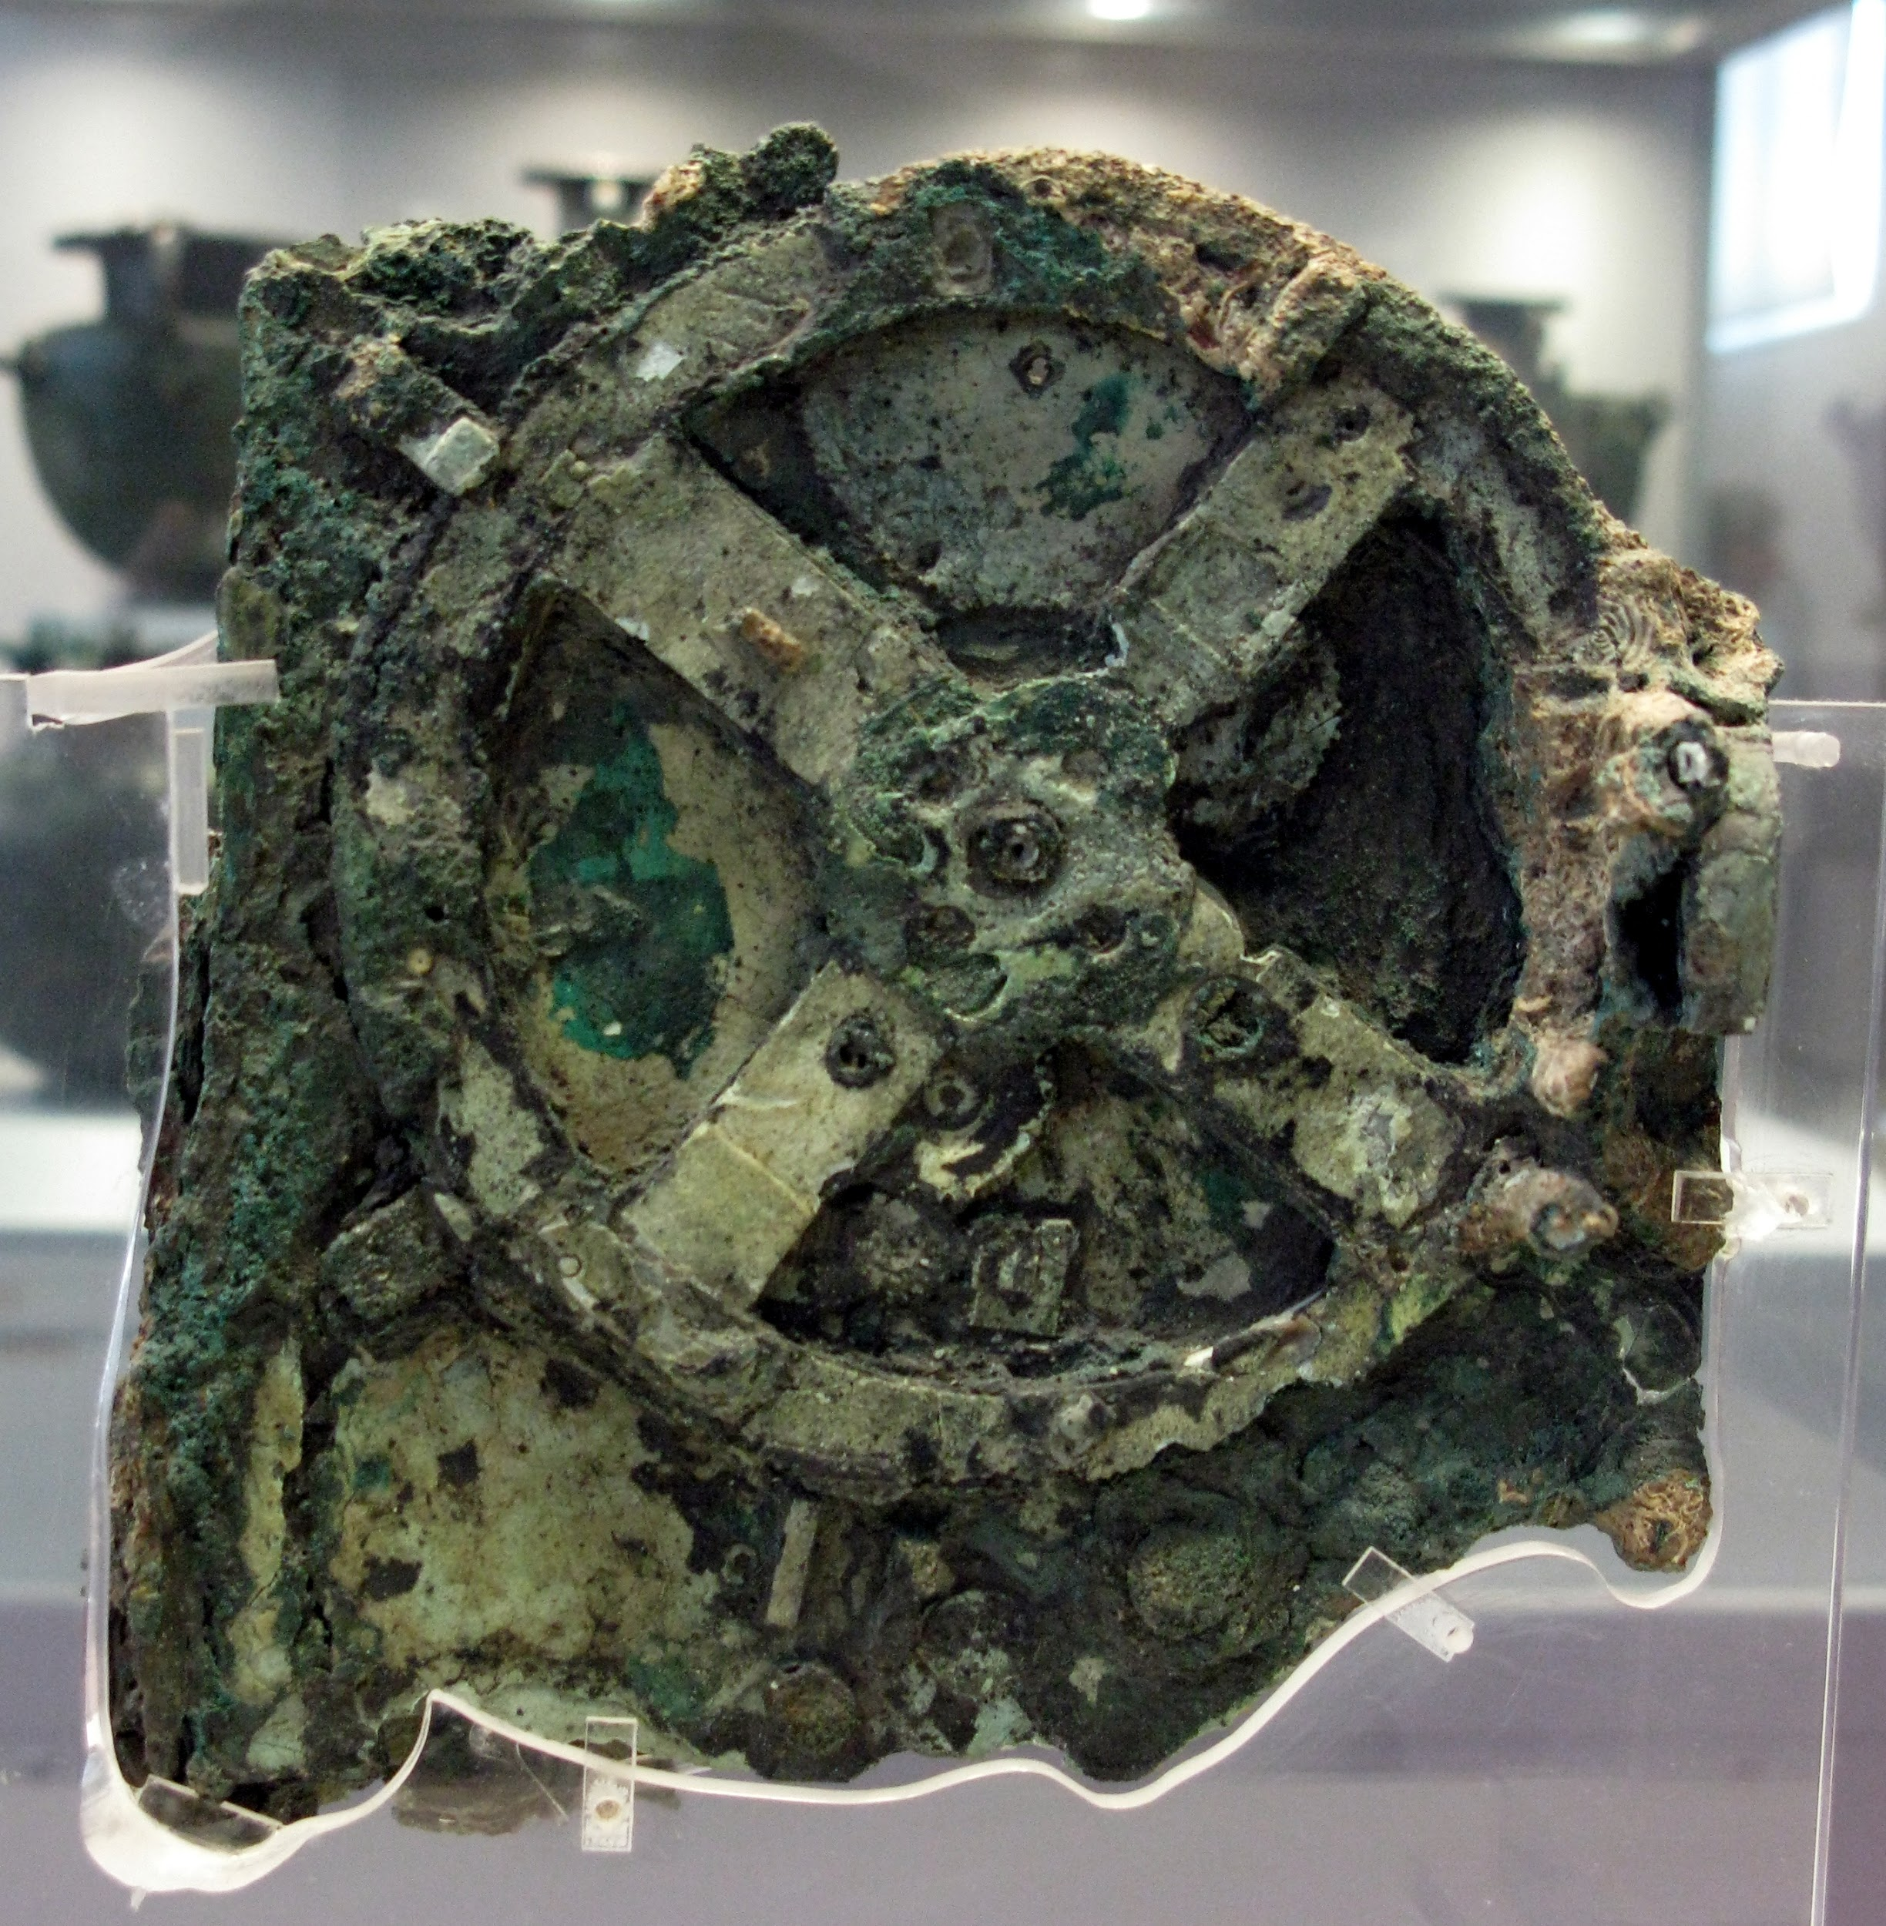
Task . Think, write, pair, share
Would you call the Antikythera mechanism a computer?

How is the mechanism similar or different to modern computers?
Similarities | Differences

To help you answer these questions, you can also ask yourself the following questions:
- Why would such a mechanism be created? What sort of problem does it solve?
- Why were computers created? How do we use them? What sort of problems do they solve?

This resource is licensed under the Open Government Licence, version 3. For more information on this licence, see ncce.io/ogl.

