System monitor

For each task in this worksheet, you will watch a **screen recording**. You will see the user performing a task, and on the right-hand side of the screen, you will see a special piece of software that monitors and visualises system resources:

* **Processor load** — usually provided as a percentage (%) of the processor’s capacity (less than 20% in the image below)
* **Main memory usage** — how much memory is occupied by the programs currently in execution, along with their data (28.2% in the image below)
* **Network activity** — how much data is being exchanged with other systems

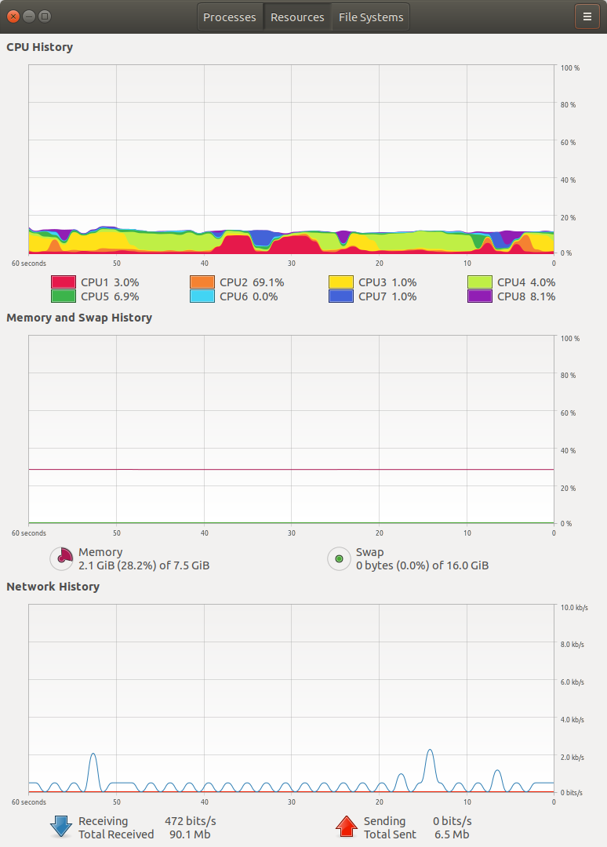

Task 1 . Idle

Watch the screen recording: Idle on Bourne to Code This is the state of the system as soon as it has finished powering up.

Make a note of the current system monitor readings.

|  |  |  |
| --- | --- | --- |
| **Processor load** | |  | | --- | |  | |
| **Main memory usage** | |  | | --- | |  | |

The user has not started any programs yet. How can you explain the fact that some percentage of the main memory is being used and the processor seems to be executing **something**?

|  |
| --- |
|  |

Task 2 . Planetarium

Watch the annotated screen recording: Planetarium on Bourne to Code.

Make a note of the system monitor readings **before** the user starts the program and **during** their interaction with it.

|  |  |  |
| --- | --- | --- |
|  | **Before the program runs**  (or after it is terminated) | **During program execution** |
| **Processor load** | |  | | --- | |  | | |  | | --- | |  | |
| **Main memory usage** | |  | | --- | |  | | |  | | --- | |  | |

Why does the processor load and the main memory usage increase during program execution?

|  |
| --- |
|  |

At what point does there seem to be some network activity? How do you explain it?

|  |
| --- |
|  |

Task 3 . Image editing

Watch the annotated screen recording: Image editing.

Make a note of the main memory usage **before** and **after** the user starts the program.

|  |  |  |
| --- | --- | --- |
|  | **Before the program runs** | **After the program starts** |
| **Main memory usage** | |  | | --- | |  | | |  | | --- | |  | |

Make a note of the main memory usage **before** and **after** the user loads the image into the program.

|  |  |  |
| --- | --- | --- |
|  | **Before the program is loaded** | **After the image is loaded** |
| **Main memory usage** | |  | | --- | |  | | |  | | --- | |  | |

Make a note of the highest value recorded for processor load and memory usage.

|  |  |
| --- | --- |
|  | **Peak value** |
| **Processor load** | |  | | --- | |  | |
| **Main memory usage** | |  | | --- | |  | |

How do you explain the fact that memory usage keeps increasing while the image is being processed? (See 0:43 to 0:58)

|  |
| --- |
|  |

Task 4 . Streaming

Watch the annotated screen recording: Streaming.

The recording contains the following steps:

1. The user starts the browser.
2. The user requests a web page. The page is retrieved and rendered.
3. The user requests the video on the web page to start streaming from the network.
4. The user terminates the browser.

Write down your observations and explanations about how the processor load, main memory usage, and network activity readings change during these steps.

|  |  |
| --- | --- |
|  | **Observations** |
| **Processor load** | |  | | --- | |  | |
| **Main memory usage** | |  | | --- | |  | |
| **Network activity** | |  | | --- | |  | |

Explorer task . Browsing

This is the scenario for the recording that you will watch:

1. The user starts the browser.
2. The user requests a web page. The page is retrieved from the network and rendered.
3. The user requests a large image. The page is retrieved from the network and displayed.
4. The user terminates the browser.

Which of the steps above would you expect to cause the most significant increase in processor load?

|  |
| --- |
|  |

Which of the steps above would you expect to cause the most significant increase in main memory usage?

|  |
| --- |
|  |

Which of the steps above would you expect to cause the most significant increase in network activity?

|  |
| --- |
|  |

Watch the following annotated screen recording on Bourne to Code, and verify your predictions: Browsing.

This resource is licensed under the Open Government Licence, version 3. For more information on this licence, see [ncce.io/ogl](http://ncce.io/ogl).