Logic circuits

For the tasks below, you will need to open a browser window and visit [circuitverse.org/simulator](http://circuitverse.org/simulator).

Task 1 . A circuit with the AND logic gate

|  |  |
| --- | --- |
| **The AND gate**   1. Go to ‘Circuit elements’ on the left. 2. Click on **Gates**. 3. Click on the AND gate. 4. Place an AND gate on the canvas. |  |
| **The inputs to the AND gate**   1. Go to ‘Circuit elements’ on the left. 2. Click on **Input**. 3. Click on the ‘Input’ box. 4. Place an input box on the canvas, to the left of the AND gate. 5. Repeat steps 7–8 to add a second input. |  |
| **The output of the AND gate**   1. Go to ‘Circuit elements’ on the left. 2. Click on **Output**. 3. Click on the ‘Output’ box. 4. Place an output box on the canvas, to the right of the AND gate. 5. Click on the ‘Digital LED’. 6. Place an LED on the canvas, to the right of the AND gate. |  |
| **The output of the AND gate**   1. Connect the first input box to one of the inputs of the AND gate (by click-dragging on the connectors, i.e. the little green circles). 2. Connect the second input box to the other input of the AND gate. 3. Connect the output of the AND gate to the output box. 4. Connect the output of the AND gate to the digital LED. |  |

You can flip an input from false (0) to true (1) and vice versa by clicking on the input box.

**Verify** that the output is true (1) and the light is turned on only when both of the inputs are true (1). The table below contains all the input combinations that you should try.

|  |  |  |  |
| --- | --- | --- | --- |
| first input  **A** | second input  **B** | AND output  **A and B** |  |
| false | false | false |
| false | true | false |
| true | false | false |
| true | true | true |

Task 2 . A new logic gate

Create the logic circuit below.

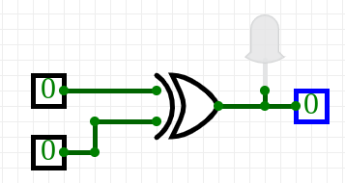

This is identical to the logic circuit that you created in the previous task, except that the AND logic gate has been replaced with an XOR logic gate. This is a new logic operation.

You can flip an input from false (0) to true (1) and vice versa by clicking on the input box.

Try all the input combinations in the table below and fill in the table with the corresponding output.

|  |  |  |
| --- | --- | --- |
| first input  **A** | second input  **B** | XOR output  **A xor B** |
| false | false |  |
| false | true |  |
| true | false |  |
| true | true |  |

Before, we described how the result of the OR operator is true if at least one of its inputs is true. How would you describe the result of the XOR logic operator with words?

|  |
| --- |
|  |

Task 3 . Security light

For the logic circuit below, there is a **single combination of input values** that will turn on the output LED.

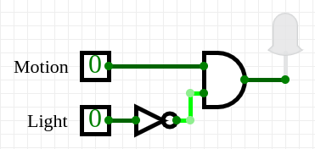

You can use logical reasoning to deduce what this combination will be, or you can create the circuit and try out the different combinations of input values. Write your answer in the table below, and provide a brief explanation for your answer.

|  |  |  |
| --- | --- | --- |
| input  **motion** | input  **light** | output |
|  |  | true |

**Explanation:**

|  |
| --- |
|  |

**Explorer question:** What is the logical expression that describes the output of this circuit?

|  |
| --- |
|  |

Explorer task . Adding binary digits

Create the logic circuit below. This is called a **half-adder**: it adds together two binary digits.

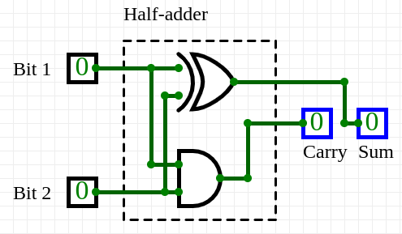

Try setting the input bits to all four possible combinations and write down the binary result, to verify that it is correct.

**Note:** As you can see in the image above, the binary result has two digits, so your answer must also contain two digits.

|  |  |  |  |  |  |  |
| --- | --- | --- | --- | --- | --- | --- |
| 0 |  | 0 |  | 1 |  | 1 |
| + 0 |  | + 1 |  | + 0 |  | + 1 |
|  |  |  |  |  |  |  |
| 010 |  | 110 |  | 110 |  | 210 |

This resource is licensed under the Open Government Licence, version 3. For more information on this licence, see [ncce.io/ogl](http://ncce.io/ogl).