Gears again

Task 1 .

Open a browser window and visit [ncce.io/tt-gears-1](http://ncce.io/tt-gears-1). You will see a geared mechanism that performs some sort of computation.

* You can set the direction of the **input gear** at the top by clicking on the gear (it can point either left or right).
* You can release a ball and **activate** the mechanism by clicking on the balls.
* After the ball goes through the mechanism, you can observe the direction of the output gear (it can point either left or right).

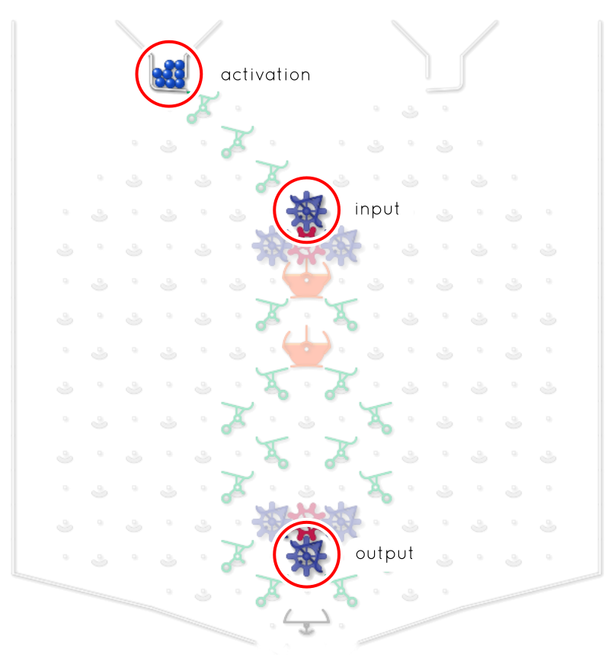

For each row in the table below:

1. Set the input gear as indicated in the table.
2. Activate the mechanism.
3. Observe and write down the output, i.e. the direction of the output gear.

|  |  |
| --- | --- |
| **Input gear** | **Output gear** |
| Gear pointing left | Gear pointing . |
| Gear pointing right | Gear pointing . |

Complete the sentence below to describe the behaviour of the mechanism.

|  |
| --- |
| The output gear points to the right when: |

Task 2 .

Open a browser window and visit [ncce.io/tt-gears-2](http://ncce.io/tt-gears-2). You will see a geared mechanism that performs some sort of computation.

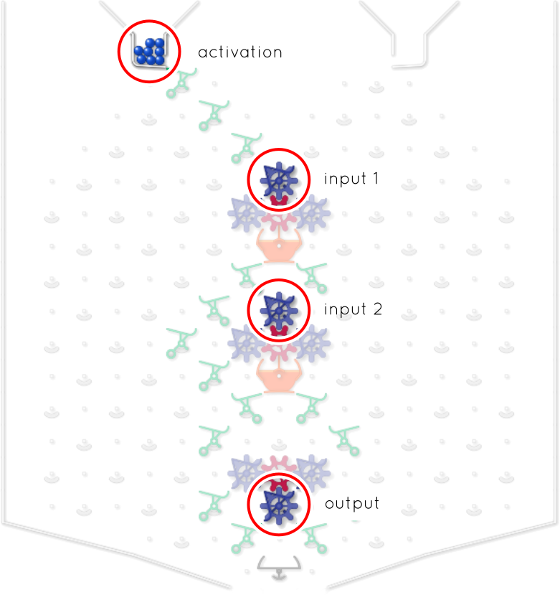

For each row in the table below:

1. Set each of the two input gears as indicated in the table.
2. Activate the mechanism.
3. Observe and write down the output, i.e. the direction of the output gear.

|  |  |  |
| --- | --- | --- |
| **Input gear 1** | **Input gear 2** | **Output gear** |
| Gear pointing left | Gear pointing left | Gear pointing . |
| Gear pointing left | Gear pointing right | Gear pointing . |
| Gear pointing right | Gear pointing left | Gear pointing . |
| Gear pointing right | Gear pointing right | Gear pointing . |

Complete the sentence below to describe the behaviour of the mechanism.

|  |
| --- |
| The output gear points to the right when: |

Explorer task .

Open a browser window and visit [ncce.io/tt-gears-3](http://ncce.io/tt-gears-3). You will see a geared mechanism that performs some sort of computation.

Initially, all the gears in the mechanism point to the left.

Release a ball to activate the mechanism and write down the new position of the gears. Repeat the process until you are able to answer the following question: what sort of computation is the machine performing?

|  |  |  |  |  |
| --- | --- | --- | --- | --- |
|  | **Gear 4**  (bottom) | **Gear 3** | **Gear 2** | **Gear 1**  (top) |
|  | Gear pointing  . | Gear pointing  . | Gear pointing  . | Gear pointing  . |
|  | Gear pointing  . | Gear pointing  . | Gear pointing  . | Gear pointing  . |
|  | Gear pointing  . | Gear pointing  . | Gear pointing  . | Gear pointing  . |
|  | Gear pointing  . | Gear pointing  . | Gear pointing  . | Gear pointing  . |
|  | Gear pointing  . | Gear pointing  . | Gear pointing  . | Gear pointing  . |
|  | Gear pointing  . | Gear pointing  . | Gear pointing  . | Gear pointing  . |
|  | Gear pointing  . | Gear pointing  . | Gear pointing  . | Gear pointing  . |
|  | Gear pointing  . | Gear pointing  . | Gear pointing  . | Gear pointing  . |

This resource is licensed under the Open Government Licence, version 3. For more information on this licence, see [ncce.io/ogl](http://ncce.io/ogl).