Video comprehension

1. What are hackers making a ‘killing’ from?
2. What dilemma did the Norwegian company face?
3. What was the message from the hackers?
4. What were 35,000 employees forced to do?
5. What were the people from Finance doing to help when they had to work without computers?
6. How many countries and how many PCs were affected?
7. How did the hackers describe the algorithms they encrypted the files with?
8. What is the virus called?

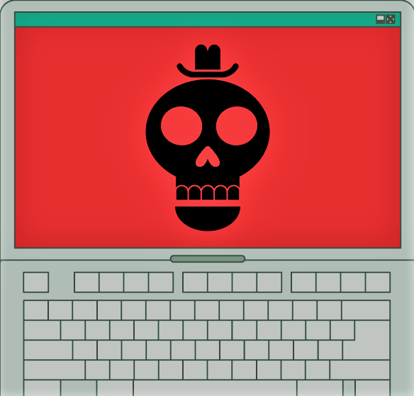

1. Why didn’t the company pay?

This resource is licensed under the Open Government Licence, version 3. For more information on this licence, see [ncce.io/ogl](http://ncce.io/ogl).